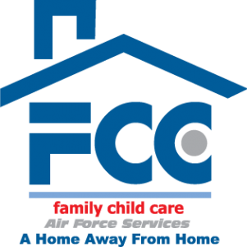
FCC Subsidy Registration Checklist
The AF FCC Subsidy program enables families, who are enrolled in full-time care with an FCC provider, to pay FCC providers at CDC rates.

- DD Form 2652
- AF FCC ECC Form (must be signed by AD member’s supervisor)
- Subsidy Parent Agreement Packet
- Subsidy Registration Checklist
- If AD: most recent LES
- If civilian: Memo from supervisor with expected hours the employee will work each week and the hourly rate. If not hourly worker, then will need their lump sum pay amount for every week or two weeks.

All documents must be scanned and emailed to the FCC Office MinotAFBFamilyChildCare@gmail.com
***Please note: all paperwork is sent to
AFSVC for approval, it can take up to three weeks for approval for this program***

